#R Code for hypergeometric likelihood plot

n <- 17

x <- 13

M <- 20

N <- 20:50

p <- dhyper(x,M,N-M,n)

plot(N, p, type="l", col="blue"

, main="Plot of Evidence about Hypergeometric Size Index (where M=20, n=17, and x=13)", xlab="N (Total population of fish)", ylab="Likelihood")

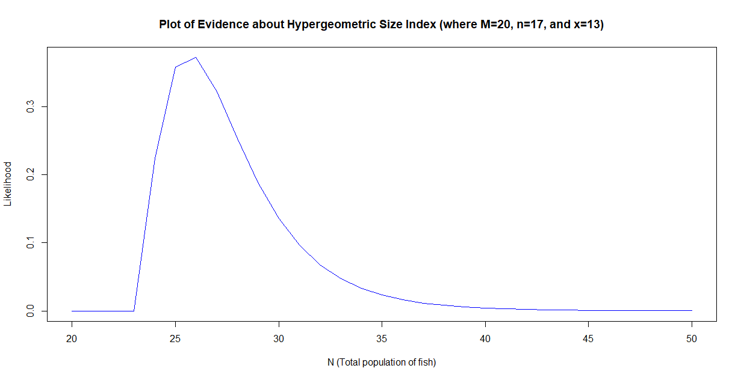

n <- 17

x <- 13

M <- 20

N <- 20:50

p <- dhyper(x,M,N-M,n)

plot(N, p, type="h", lwd=2, col="blue"

, main="Plot of Evidence about Hypergeometric Size Index (where M=20, n=17, and x=13)", xlab="N (Total population of fish)", ylab="Likelihood")

